Service Qualification REST SPECIFICATION

TMF645

Document Version: : <V0.1>

Date: Mar, 2016

Document Status: Draft

# NOTICE

Copyright © TeleManagement Forum 2013. All Rights Reserved.

This document and translations of it may be copied and furnished to others, and derivative works that comment on or otherwise explain it or assist in its implementation may be prepared, copied, published, and distributed, in whole or in part, without restriction of any kind, provided that the above copyright notice and this section are included on all such copies and derivative works. However, this document itself may not be modified in any way, including by removing the copyright notice or references to TM FORUM, except as needed for the purpose of developing any document or deliverable produced by a TM FORUM Collaboration Project Team (in which case the rules applicable to copyrights, as set forth in the [TM FORUM IPR Policy](http://www.tmforum.org/IPRPolicy/11525/home.html), must be followed) or as required to translate it into languages other than English.

The limited permissions granted above are perpetual and will not be revoked by TM FORUM or its successors or assigns.

This document and the information contained herein is provided on an "AS IS" basis and TM FORUM DISCLAIMS ALL WARRANTIES, EXPRESS OR IMPLIED, INCLUDING BUT NOT LIMITED TO ANY WARRANTY THAT THE USE OF THE INFORMATION HEREIN WILL NOT INFRINGE ANY OWNERSHIP RIGHTS OR ANY IMPLIED WARRANTIES OF MERCHANTABILITY OR FITNESS FOR A PARTICULAR PURPOSE.

Direct inquiries to the TM Forum office:

240 Headquarters Plaza,

East Tower – 10th Floor,

Morristown, NJ  07960 USA

Tel No.  +1 973 944 5100

Fax No.  +1 973 944 5110

TM Forum Web Page: [www.tmforum.org](http://www.tmforum.org/)

TM Forum Web Page: [www.tmforum.org](http://www.tmforum.org/)

# Table of Contents

NOTICE 2

Table of Contents 3

List of Tables 4

Introduction 5

SAMPLE USE CASES 7

RESOURCE MODEL 9

Managed Entity and Task Resource Models 9

Service qualification Resource 9

Order feasibility check Resource 15

Event Models 20

API OPERATION TEMPLATES 21

GET /api/serviceQualificationRequest?{filter_representation} 22

POST /api/serviceQualificationRequest 25

GET /api/orderFeasibilityCheckRequest 33

POST /api/orderFeasibilityCheckRequest 35

API NOTIFICATION TEMPLATES 39

Release History 40

# List of Tables

Table 1 Service Qualification field description 15

# Introduction

Service Qualification API is One of Pre-Ordering Management API Family. Service Qualification API goal is to provide service availability at Customer location.

In the Open Digital Economy where multiple actors (SDPs, CSPs, …) may be involved with the delivery of an end-to-end service, those actors need to collaborate and interact with the customer as needed.

ServiceQualification API operation checks are modeled as requests:

- serviceQualification request checks technical eligibility (Service Qualification Request resource),

- productOfferingQualification request checks commercial Eligibility include technical eligibility. (productOfferingQualification resource)

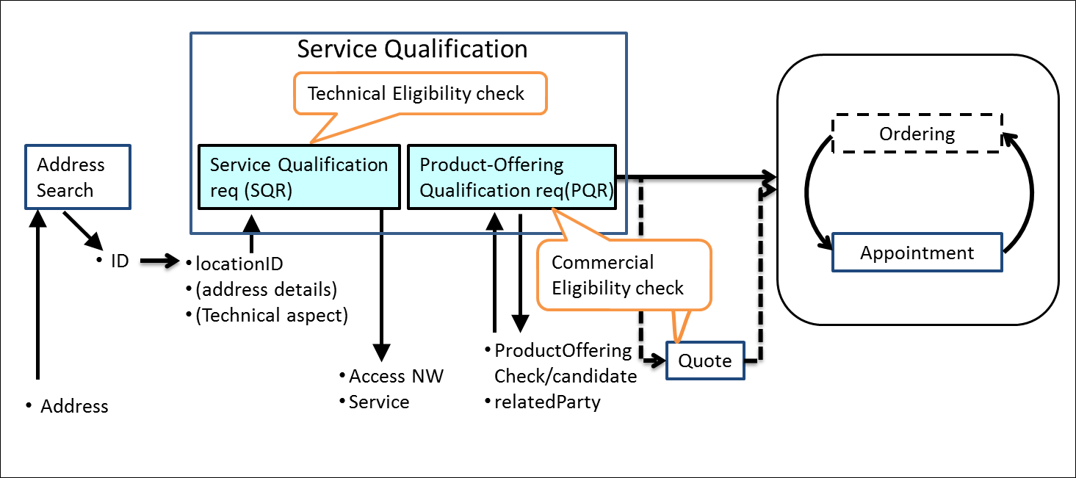

serviceQualificationRequest

* Check if a location (identified by address) is within the service footprint (i.e. within a serving area) and the type of service technology available at the location (i.e. access technology like Fiber, Wireless or Interim Satellite but also sensor data feed or utility service, HDTV availability), where detail response indicates technical parameters of service (e.g. bandwidth, data feed interval and accuracy, pipe diameter for water, etc).
* Intended for use cases where the “middle B[1]” (retail ISP, reseller, etc) is not concerned about the product offering, but only about the service parameters.
* Allows for asynchronous responses via notification hub for checks that take longer.
* Should allow for serviceQualificationRequest for all types of services in a generic way, not only communication service access. If a telecom is sent a serviceQualificationRequest it will respond with the network access technology and parameters available at the location. If an electricity supplier is sent a request, it will respond with the options on electritity (volts?) available at the location, when a water utility is sent a request, it will respond with service parameters available at the location (pipe diameter, pressure, )

productOfferingQualification request

* Check if a given product offering can be delivered to a specific location (identified by address).
* Provide available product offering options if a specific product is not requested/given Synchronous responses only
* Is about product offering level eligibility, where the “middle B” (reseller, etc) is not primarily concerned about technical parameters, but about product offering availability at location.

Depending on the way to describe “Product “, it may be classified in either technical feasibility or commercial feasibility.

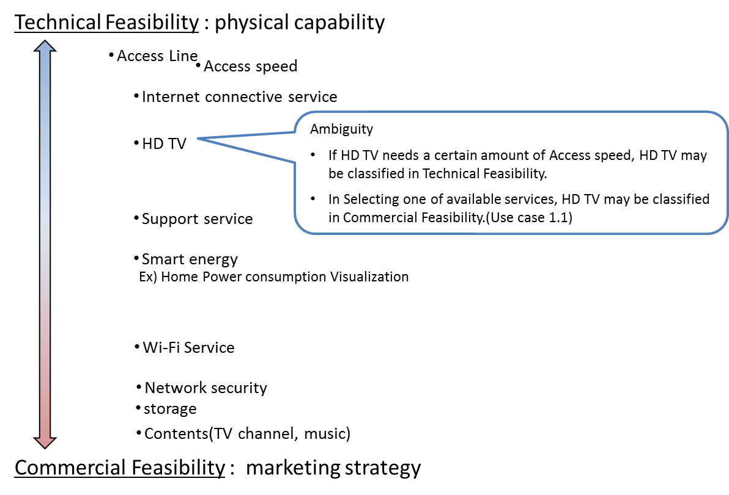

# SAMPLE USE CASES

The following table maps out the use case.

|  |  |
| --- | --- |
| **UC** | **description** |
| 1 | A ‘new’ **customer** is browsing operator internet services webpage and **wish to see** which **offers** he is **eligible** with his current address. The **system** **retrieves** the **list of offers** technically eligible **with characteristics and configuration**. |
| 1.1 | Configuration could be detailed and for example the **customer** is **informed** that he is **eligible** **for** ADSL, TV online but he cannot have both TV HD and Multi-Screen TV options (just **one of these**). |
| 2 | A ‘new’ **customer** is interested for FTTH service – he **asks** to SP sale representative about **FTTH** service at his current address. Thus **system indicate** he is **eligible to FTTH** and he will have a **xx Mo/s speed** for download and yy for upload. |
| 2.2 | Alternative: the address is **ok for FTTH** service but from a strictly technical point of view the operator **FTTH center box** have **not enough space** to plug a new connection. The **Sale** representative is able to **inform** the customer that he will be **eligible to FTTH in 8 week** |
| 3 | a **customer wishes to enjoy HD TV.** He asks to SP sale representative. He is **eligible** but he **has to change** his **access** offer. |
| 3.1 | Alternative: **Access is ok** but system checks that he is currently using an outdated TV decoder and he has to **upgrade** his **TV box** to enjoy HD. |
| 4 | A **customer** **askes for TV on internet.** An eligibility **check** is triggered and should check not only the **TV channel** provided **by the SP** but also the additionally **TV channels availability** at the customer address (even if they not directly provided by the SP). |
| 5 | A **customer** is moving to a new address – a **check** must be done at this new **address** and the **SP** sale representative is able to **inform** the customer if:   * he will be **able to keep** current offer at his new address * he **should downgrade** his services because current ones are not technically feasible at the new address * he can keep but also he is **eligible to** an **upgrade** and benefit for example to a FTTH broadband at his new address. |
| 6 | A **TV channel provider** wants to sell a set of channel for a customer. He will ask for the customer **broadband company** [API provider] and an **access id** (email address for example). He will use this information with this POST /serviceQualificationRequest api to be able to **retrieve** information on customer **access capabilities** (and check if the customer will be able to get his service from the service point). |
| 7 | A **MVNO/other provider** who use provider network will call this api to be able to **check capabilities** for one prospect. With this api he will have all technical information and he should have to apply his own commercial rules to make a proposal to this customer. This UC could be a mandatory one for contractual reason where network is still owned by legacy Telco Company but they have to open it for competitors. |
| 8 | this api could be used in **internal channel** to be able to check technical **capabilities** without any commercial filter. It could be useful in some customer support UC. |
| 9 | a customer wishes to enjoy HD TV and internet by Fiber and to use call by ADSL. He asks to SP sale representative. |

# RESOURCE MODEL

## Managed Entity and Task Resource Models

Service Qualification API has 2 Resources (subclassing Business Interaction).

Service Qualification Request resource for knowing the allowed services based on specific criterions such as

* [IN] location
* [OUT] Access NW
* [OUT] Service

productOfferingQualification resource for knowing the product offering based on specific criterions such as

* [IN/OUT]ProductOffering
* [IN] location (optional)
* [IN]related party (cf. party id, channel)

### Service qualification Resource

4 Example of the JSON representation of Service Qualification:

1. Address id for location info
2. Address discription for location info
3. Geocode for location info
4. Public-key for location info

Service provider execute service qualification request with location information to get technical eligibility that is network access speed, available service list.

1. Address id for location info

|  |
| --- |
| {  // Service Qualification Request  "serviceQualificationRequest" : {  "id" : "",  "eligibilityDate" : "20160201 10:00",  // 1 of Address, Address description, geoCode and publicKey should be provided  "address" : {  "id" : "12345678",  "href" : "https://www.google.ca/maps/dir/''/google+map+montreal+place+ville+marie/@45.5014452,-73.6393962,12z/data=!3m1!4b1!4m8!4m7!1m0!1m5!1m1!1s0x4cc91a4498f8f3db:0xa2760b4a779d61d3!2m2!1d-73.5693564!2d45.5014666",  },  "serviceSpecification" : [  {  "id":"3333"  }  ],  "serviceCharacteristic" : [  {  "id":"downstreamspeed",  "value" : "6MBPS"  }  ],  "serviceCategory" : [  {  "id":"TVservice"  }  ],  "provideAlternative" : "No",  "provideOnlyEligible" : "Yes"  },  //  // Service Qualification Response  //  "serviceQualificationResponse" : {  "id" : "42",  "eligibilityDate" : "20160201 10:00",  // array of physical resource or Logical resource (e.g physicalTerminationPoint) is needed for multiple access nw representation  "physicalTerminationPoint" : [  {  "accessType" : "ADSL",  },  {  "accessType" : "Fiber",  }  ],  "address" : {  "id" : "12345678",  "href" : "https://www.google.ca/maps/dir/''/google+map+montreal+place+ville+marie/@45.5014452,-73.6393962,12z/data=!3m1!4b1!4m8!4m7!1m0!1m5!1m1!1s0x4cc91a4498f8f3db:0xa2760b4a779d61d3!2m2!1d-73.5693564!2d45.5014666",  },  "serviceSpecification" : [  {  "id" : "2222",  "href": "https://serviceSpecification/ADSL",  "serviceCategoryId" : "Internet",  "ServiceSpecificationCharacteristic" : [  {  "id" : "2211",  "name" : "upstreamSpeed",  "valuefrom" : "10KBPS",  "valueto" : "1MBPS"  },  {  "id" : "2212",  "name" : "downstreamSpeed"  "valuefrom" : "100KBPS",  "valueto" : "6MBPS"  }  ],  "serviceQualification" : {  "qualificationResult" : "available"  }  },  {  "id" : "3333",  "href": "https://serviceSpecification/TVservice",  "serviceCategoryId" : "TV",  "serviceQualification" : {  "qualificationResult" : "unavailable",  "comment" : "less than 5MBPS bandwidth",  "qualificationResultDate" : "2016/02/01"  }  }  ],  // Alternative service which be able to satisfy the request.  "Alternative" : [  {  "serviceSpecificationId" : "Fiber",  "attribute" : [  {  "id" : "2212",  "name" : "upstreamSpeed",  "value" : "1MBPS"  },  {  "id" : "2212",  "name" : "downstreamSpeed",  "value" : "10MBPS"  },  ]  }  ]  }  } |

1. Address discription for location info

|  |
| --- |
| {  // Service Qualification Request  "serviceQualificationRequest" : {  "id" : "",  "eligibilityDate" : "20160201 10:00",  // 1 of Address, Address description, geoCode and publicKey should be provided  "addressDescription" : {  "streetNr" : "1",  "streetName" : "ville Marie",  "city" : "montreal",  "stateOrProvince" : "Quebec",  "country" : "Canada ",  },  "serviceSpecification" : [  {  "id":"3333"  }  ],  "serviceCharacteristic" : [  {  "id":"downstreamspeed",  "value" : "6MBPS"  }  ],  "serviceCategory" : [  {  "id":"TVservice"  }  ],  "provideAlternative" : "No",  "provideOnlyEligible" : "Yes"  },  //  // Service Qualification Response  //  "serviceQualificationResponse" : {  "id" : "42",  "eligibilityDate" : "20160201 10:00",  // array of physical resource or Logical resource (e.g physicalTerminationPoint) is needed for multiple access nw representation  "physicalTerminationPoint" : [  {  "accessType" : "ADSL",  },  {  "accessType" : "Fiber",  }  ],  "address" : {  "id" : "12345678",  "href" : "https://www.google.ca/maps/dir/''/google+map+montreal+place+ville+marie/@45.5014452,-73.6393962,12z/data=!3m1!4b1!4m8!4m7!1m0!1m5!1m1!1s0x4cc91a4498f8f3db:0xa2760b4a779d61d3!2m2!1d-73.5693564!2d45.5014666",  },  "addressDescription" : {  "streetNr" : "1",  "streetName" : "ville Marie",  "city" : "montreal",  "stateOrProvince" : "Quebec",  "country" : "Canada ",  },  "serviceSpecification" : [  {  "id" : "2222",  "href": "https://serviceSpecification/ADSL",  "serviceCategoryId" : "Internet",  "ServiceSpecificationCharacteristic" : [  {  "id" : "2211",  "name" : "upstreamSpeed",  "valuefrom" : "10KBPS",  "valueto" : "1MBPS"  },  {  "id" : "2212",  "name" : "downstreamSpeed"  "valuefrom" : "100KBPS",  "valueto" : "6MBPS"  }  ],  "serviceQualification" : {  "qualificationResult" : "available"  }  },  {  "id" : "3333",  "href": "https://serviceSpecification/TVservice",  "serviceCategoryId" : "TV",  "serviceQualification" : {  "qualificationResult" : "unavailable",  "comment" : "less than 5MBPS bandwidth",  "qualificationResultDate" : "2016/02/01"  }  }  ],  // Alternative service which be able to satisfy the request.  "Alternative" : [  {  "serviceSpecificationId" : "Fiber",  "attribute" : [  {  "id" : "2211",  "name" : "upstreamSpeed",  "value" : "1MBPS"  },  {  "id" : "2212",  "name" : "downstreamSpeed",  "value" : "10MBPS"  },  ]  }  ]  }  } |

1. Geocode for location info

|  |
| --- |
| {  // Service Qualification Request  "serviceQualificationRequest" : {  "id" : "",  "eligibilityDate" : "20160201 10:00",  // 1 of Address, Address description, geoCode and publicKey should be provided  "geocode" : {  "latitude" : "73.6393962",  "longitude" : "45.5014452",  },  "serviceSpecification" : [  {  "id":"3333"  }  ],  "serviceCharacteristic" : [  {  "id":"downstreamspeed",  "value" : "6MBPS"  }  ],  "serviceCategory" : [  {  "id":"TVservice"  }  ],  "provideAlternative" : "No",  "provideOnlyEligible" : "Yes"  },  //  // Service Qualification Response  //  "serviceQualificationResponse" : {  "id" : "42",  "eligibilityDate" : "20160201 10:00",  // array of physical resource or Logical resource (e.g physicalTerminationPoint) is needed for multiple access nw representation  "physicalTerminationPoint" : [  {  "accessType" : "ADSL",  },  {  "accessType" : "Fiber",  }  ],  "address" : {  "id" : "12345678",  "href" : "https://www.google.ca/maps/dir/''/google+map+montreal+place+ville+marie/@45.5014452,-73.6393962,12z/data=!3m1!4b1!4m8!4m7!1m0!1m5!1m1!1s0x4cc91a4498f8f3db:0xa2760b4a779d61d3!2m2!1d-73.5693564!2d45.5014666",  },  "geocode" : {  "latitude" : "73.6393962",  "longitude" : "45.5014452",  },  "serviceSpecification" : [  {  "id" : "2222",  "href": "https://serviceSpecification/ADSL",  "serviceCategoryId" : "Internet",  "ServiceSpecificationCharacteristic" : [  {  "id" : "2211",  "name" : "upstreamSpeed",  "valuefrom" : "10KBPS",  "valueto" : "1MBPS"  },  {  "id" : "2212",  "name" : "downstreamSpeed"  "valuefrom" : "100KBPS",  "valueto" : "6MBPS"  }  ],  "serviceQualification" : {  "qualificationResult" : "available"  }  },  {  "id" : "3333",  "href": "https//serviceSpecification/TVservice",  "serviceCategoryId" : "TV",  "serviceQualification" : {  "qualificationResult" : "unavailable",  "comment" : "less than 5MBPS bandwidth",  "qualificationResultDate" : "2016/02/01"  }  }  ],  // Alternative service which be able to satisfy the request.  "Alternative" : [  {  "serviceSpecificationId" : "Fiber",  "attribute" : [  {  "id" : "2211",  "name" : "upstreamSpeed",  "value" : "10MBPS"  },  {  "id" : "2212",  "name" : "downstreamSpeed",  "value" : "10MBPS"  },  ]  }  ]  }  } |

1. Public-key for location info

|  |
| --- |
| {  // Service Qualification Request  "serviceQualificationRequest" : {  "id" : "",  "eligibilityDate" : "20160201 10:00",  // 1 of Address, Address description, geoCode and publicKey should be provided  "publicKey" : "public-Key_ 00000000",  "serviceSpecification" : [  {  "id":"3333"  }  ],  "serviceCharacteristic" : [  {  "id":"downstreamspeed",  "value" : "6MBPS"  }  ],  "serviceCategory" : [  {  "id":"TVservice"  }  ],  "provideAlternative" : "No",  "provideOnlyEligible" : "Yes"  },  //  // Service Qualification Response  //  "serviceQualificationResponse" : {  "id" : "42",  "eligibilityDate" : "20160201 10:00",  // array of physical resource or Logical resource (e.g physicalTerminationPoint) is needed for multiple access nw representation  "physicalTerminationPoint" : [  {  "accessType" : "ADSL",  },  {  "accessType" : "Fiber",  }  ],  "publicKey" : "public-Key_ 00000000",  "serviceSpecification" : [  {  "id" : "2222",  "href": "https:https://serviceSpecification/ADSL",  "serviceCategoryId" : "Internet",  "ServiceSpecificationCharacteristic" : [  {  "id" : "2211",  "name" : "upstreamSpeed",  "valuefrom" : "10KBPS",  "valueto" : "1MBPS"  },  {  "id" : "2212",  "name" : "downstreamSpeed"  "valuefrom" : "100KBPS",  "valueto" : "6MBPS"  }  ],  "serviceQualification" : {  "qualificationResult" : "available"  }  },  {  "id" : "3333",  "href": "https://serviceSpecification/TVservice",  "serviceCategoryId" : "TV",  "serviceQualification" : {  "qualificationResult" : "unavailable",  "comment" : "less than 5MBPS bandwidth",  "qualificationResultDate" : "2016/02/01"  }  }  ],  // Alternative service which be able to satisfy the request.  "Alternative" : [  {  "serviceSpecificationId" : "Fiber",  "attribute" : [  {  "id" : "2211",  "name" : "upstreamSpeed",  "value" : "11MBPS"  },  {  "id" : "2212",  "name" : "downstreamSpeed",  "value" : "10MBPS"  },  ]  }  ]  }  } |

For each resource in your model fill the following table.

Fields Description

ServiceQualificationRequest

| Field | Description |
| --- | --- |
| Id | Unique identifier for Interaction. |
| eligibilityDate | The Date requested eligibility |
| Address |  |
| Type | Unique identifier for Place |
| Id | Unique identifier for Place |
| Href | Reference of a place (for instance in google map) |
| address description | Address description |
| streetNr |  |
| streetNrSuffix |  |
| streetName |  |
| streetType |  |
| streetSuffix |  |
| City |  |
| locality |  |
| postcode |  |
| stateOrProvince |  |
| country |  |
| geoCode | Geographic code |
| latitude | Latitude |
| Longitude | Longitude |
| geographicDatum |  |
| publicKey | a landline number or an internet access id |
| serviceSpecification | Requested service specification |
| Id | Unique identifier for serviceSpecification |
| serviceCharacteristic |  |
| Id | Servicecharactristic for requested service |
| Value | serviceCharacteristic value for requested service |
| serviceCategory |  |
| Id |  |
| provideAlternative | if this flag I set to Yes - the API will retrieve closest value available for this same service |
| provideOnlyEligible | used to restrict API response to only available services.  If this flag is set to No the API will provide both positive and negative eligibility results. |
|  |  |

ServiceQualification Response

| Field | Description |
| --- | --- |
| Id | Unique identifier for Interaction. |
| eligibilityDate |  |
| address |  |
| type | Unique identifier for Place |
| Id | Unique identifier for Place |
| href | Reference of a place (for instance in google map) |
| publicKey | a landline number or an internet access id |
| physicalResource | Array of physical resource for multiple access NW |
| physicalTerminationPoint | Logical resource for multiple access NW |
| accessType | Access Technology Type: ADSL, VDSL, fiber |
| serviceSpecification | Service specification for qualification service |
| Id |  |
| serviceCategoryId | Category id for requested service |
| serviceSpecificationCharacteristic | Characteristic for requested service |
| Id |  |
| value |  |
| serviceQualification | services with a specific eligibility check will be listed there with technical eligibility result |
| qualificationResult | Technical eligibility result: service availability status which explain below |
| comment | Comment for technical eligibility result |
| qualificationResultDate | qualification judgement date |
| alternative | To retrieve closest value available for this same service, If the provideAlternative flag in request set to Yes, |
| serviceSpecificationId | Alternative service specification for alternative service |
| attribute | Alternative service specification |
| id |  |
| value |  |
|  |  |
|  |  |

Table 1 Service Qualification field description

Serviceability status may be represented the following table.

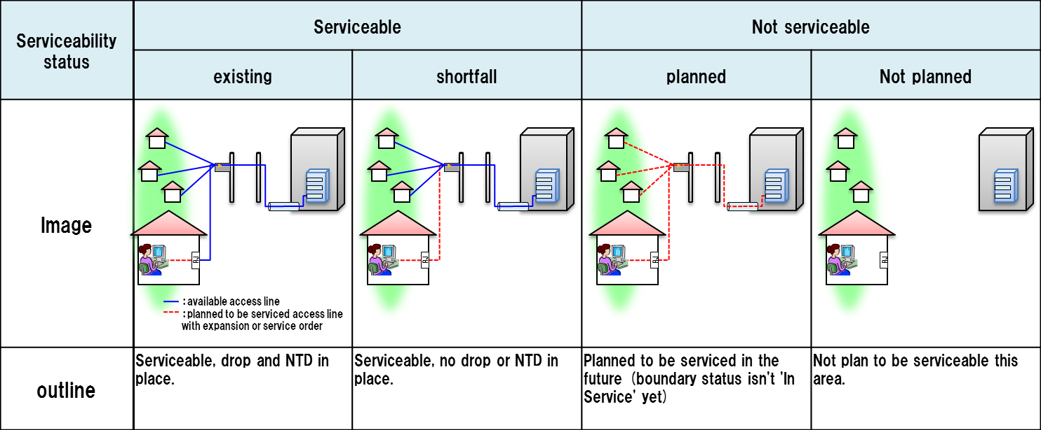

serviceable-shortfall is include updating access NW.

substatus are captured via notation

i.e serviceable.existing etc…

In the case that the service provider or broker responding to the request already knows about an upcoming change in the serviceability status, it is intended that the response is sent as a collection of the about results, listing both the current and the future valid response with its state and a matching eligibility date.

### Product-Offering Qualification Resource

Example of the JSON representation of Product-Offering Qualification:

Service provider execute Product-Offering Qualification request to get the customer location Feasibility include Commercial and Technical eligibility.

|  |
| --- |
| {  // Product-Offering Qualification Request  "productOfferingQualificationRequest" : {  "partyId" : "service_provider_0001",  "channel" : "web store",  "productInventoryId" : "ADSL_locate_No",  // location info is optional in product-offering qualification  "address" : {  "id" : "12345678",  },  "productOfferingSpecification" : [  {  "id":"3333"  }  ],  "productOfferingCategory" : [  {  "id":"TVservice with Internet Play"  }  ],  "productCharacteristic" : [  {  "id":"downstreamspeed",  "value" : "6MBPS"  }  ],  "provideOnlyAvailable" : "Yes",  "provideUnavailabilityReason" : "No"  },  //  // Product-Offering Qualification Response  //  "productOfferingQualificationResponse" : {  "productOfferingSpecification" : [  {  "id" : "3333",  "productOfferingCategoryId" : "TV service with internet play",  "productCharacteristic" : [  {  "id" : "upstreamspeed",  "value" : "500 Kbps"  },  {  "id" : "downstreamspeed",  "value" : "4 Mbps"  }  ],  "orderFeasibilityCheck" : {  "eligibilityResult" : "unavailability"  "eligibilityUnavailablityReason" : [  {  "code" : "UNAVAILABLE-300",  "label" : "need more bandwidth"  }  ]  }  }  ]  }  } |

For each resource in your model fill the following table.

Fields Description

ProductOfferingQualificationRequest

| Field | Description |
| --- | --- |
| partyId | Unique identifier for party |
| channel | Channel |
| productInventoryId | Product Inventory ID for commercial eligibility |
| address |  |
| id | Unique identifier for Place |
| href | Reference of a place (for instance in google map) |
| address description | Address description |
| streetNr |  |
| streetNrSuffix |  |
| streetName |  |
| streetType |  |
| streetSuffix |  |
| city |  |
| locality |  |
| postcode |  |
| stateOrProvince |  |
| country |  |
| geoCode | Geographic code |
| latitude | Latitude |
| Longitude | Longitude |
| geographicDatum |  |
| publicKey | a landline number or an internet access id |
| productOfferingSpecification | Requested product-offering specification |
| id |  |
| productOfferingCategory | Requested product-offering category |
| id |  |
| productOfferingCharacteristic | A characteristic quality or distinctive feature of a product-Offering |
| id |  |
| value |  |
| provideOnlyAvailable | If this flag is set to No the API will provide both positive and negative availability results. |
| provideUnavailabilityReason | add in the API the rational for not-authorized productOffering. The rationales for non-authorized are described in the eligibilityUnvailabilityReason structure in the response. |
|  |  |

ProductOfferingQualification Response

| Field | Description |
| --- | --- |
| productOfferingSpecification |  |
| Id | ID of the top level productOffering |
| productOfferingCategoryId | Unique identifier for productOfferingCategory |
| productCharacteristic |  |
| id | Unique identifier for productCharacteristic |
| value | The value for productCharacteristic in this productOffering |
| orderFeasibilityCheck | Commercial and Technical eligibility result for this offer: |
| eligibilityResult | Eligibility result for this offer |
| eligibilityUnavailabilityReason | reason for eligibility result if the offer was unavailable |
| code | Unavailable reason code |
| label | Unavailable reason label |

For each resource in the API provide a UML model:

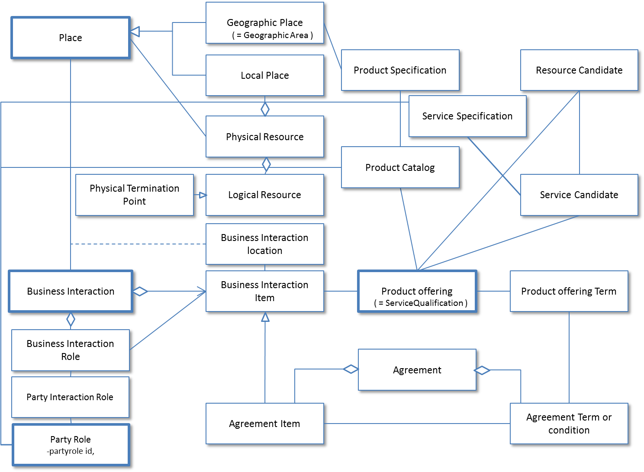

Figure 1 – Service Qualification resource model

# Event Models

Service Qualification API has no notification event.

# API OPERATION TEMPLATES

For every single of operation on the entities use the following templates and provide sample REST requests and responses.

Remember that the following Uniform Contract rules must be used :

|  |  |  |
| --- | --- | --- |
| Operation on Entities | Uniform API Operation | Description |
| Query Entities | GET Resource | GET must be used to retrieve a representation of a resource. |
| Create Entity | POST Resource | POST must be used to create a new resource |
| Partial Update of an Entity | PATCH Resource | PATCH must be used to partially update a resource |
| Complete Update of an Entity | PUT Resource | PUT must be used to completely update a resource identified by its resource URI |
| Remove an Entity | DELETE Resource | DELETE must be used to remove a resource |
| Execute an Action on an Entity | POST on TASK Resource | POST must be used to execute Task Resources |
| Other Request Methods | POST on TASK Resource | GET and POST must not be used to tunnel other request methods. |

Filtering and attribute selection rules are described in the TMF REST Design Guidelines.

Notifications are also described in a subsequent section.

## GET /api/serviceQualificationRequest?{filter_representation}

Description :

This operation is used to provide technical Eligibility that is what service is available or when the service is available.

Partner used this API to notice service availability Partner’s customer.

GET operation use if location id is created at other API/system.

|  |  |  |  |
| --- | --- | --- | --- |
| **Attribute name** | **Mandatory** | **Default** | **Rule** |
| Id | N | Blank |  |
| eligibilityDate | N | Today |  |
| Address | N |  | Address info need one from any address representaions |
| Address description | N |  | Address info need one from any address representaions |
| geoCode | N |  | Address info need one from any address representaions |
| publicKey | N |  | Address info need one from any address representaions |
| serviceSpecification | N |  |  |
| serviceCharacteristic | N |  |  |
| serviceCategory | N |  |  |
| provideAlternative | N | “No” | if this flag I set to Yes - the API will retrieve closest value available for this same service |
| provideOnlyEligible | N | “Yes” | If this flag is set to No the API will provide both positive and negative eligibility results |

Behavior :

* Return status codes
  + 200 OK – the request was successful
  + 400 Bad Request – error, for example to cover these functional error cases:
    - Location is not exist

Use case : Get access network service availability from location id

|  |
| --- |
| **REQUEST** |
| GET /api/serviceQualificationRequest?place.id=12345678;  Accept: application/json |
| **RESPONSE** |
| 200  Content-Type: application/json  {  "id" : "42",  "eligibilityDate" : "20160201 10:00",  "physicalTerminationPoint" : [  {  "accessType" : "ADSL",  },  {  "accessType" : "Fiber",  }  ],  "address" : {  "id" : "12345678",  "href" : "https://www.google.ca/maps/dir/''/google+map+montreal+place+ville+marie/@45.5014452,-73.6393962,12z/data=!3m1!4b1!4m8!4m7!1m0!1m5!1m1!1s0x4cc91a4498f8f3db:0xa2760b4a779d61d3!2m2!1d-73.5693564!2d45.5014666",  },  "serviceSpecification" : [  {  "id" : "2222",  "href": "https://serviceSpecification/ADSL",  "serviceCategoryId" : "Internet",  "ServiceSpecificationCharacteristic" : [  {  "name" : "uploadSpeed",  "valuefrom" : "10KBPS",  "valueto" : "1MBPS"  },  {  "name" : "downloadSpeed"  "valuefrom" : "100KBPS",  "valueto" : "6MBPS"  }  ],  "serviceQualification" : {  "qualificationResult" : "available"  }  },  {  "id" : "3333",  "href": "https://serviceSpecification/TVservice",  "serviceCategoryId" : "TV",  "serviceQualification" : {  "qualificationResult" : "available"  }  }  ]  } |

## POST /api/serviceQualificationRequest

Description :

This operation is used to provide technical Eligibility that is what service is available or when the service is available.

Partner used this API to notice service availability Partner’s customer.

POST operation use if location id is create at this operation.

|  |  |  |  |  |  |  |
| --- | --- | --- | --- | --- | --- | --- |
| **Attribute name** | | **Mandatory** | | **Default** | | **Rule** |
| Id | | N | | Blank | |  |
| eligibilityDate | | N | | Today | |  |
| Address | | N | |  | | Address info need one from any address representaions |
| Address description | | N | |  | | Address info need one from any address representaions |
| geoCode | | N | |  | | Address info need one from any address representaions |
| publicKey | | N | |  | | Address info need one from any address representaions |
| serviceSpecification | | N | |  | |  |
| serviceCharacteristic | | N | |  | |  |
| serviceCategory | | N | |  | |  |
| provideAlternative | | N | | “No” | | if this flag I set to Yes - the API will retrieve closest value available for this same service |
| provideOnlyEligible | | N | | “Yes” | | If this flag is set to No the API will provide both positive and negative eligibility results |

Behavior :

* Return status codes
  + 200 OK – the request was successful
  + 400 Bad Request – error, for example to cover these functional error cases:
    - Location is not exist

Use case :

3 Examples for a Specific Service

* with Location
* with Location and Physical Characteristics
* with Service Specification and Characteristics

We assume requests are synchronous (i.e. responses are sent synchronously)

1) Which services can be provided at a specific location?

|  |
| --- |
| **REQUEST** |
| POST /api/serviceQualificationRequest  Accept: application/json  {  “address” : {  “href” : “https://www.google.ca/maps/dir/''/google+map+montreal+place+ville+marie/@45.5014452,-73.6393962,12z/data=!3m1!4b1!4m8!4m7!1m0!1m5!1m1!1s0x4cc91a4498f8f3db:0xa2760b4a779d61d3!2m2!1d-73.5693564!2d45.5014666”  }  } |
| **RESPONSE** |
| 200  Content-Type: application/json  {  "id" : "42",  "eligibilityDate" : "20160201 10:00",  "physicapTerminationPoint" : [  {  "accessType" : "ADSL",  },  {  "accessType" : "Fiber",  }  ],  "address" : {  "id" : "12345678",  "href" : "https://www.google.ca/maps/dir/''/google+map+montreal+place+ville+marie/@45.5014452,-73.6393962,12z/data=!3m1!4b1!4m8!4m7!1m0!1m5!1m1!1s0x4cc91a4498f8f3db:0xa2760b4a779d61d3!2m2!1d-73.5693564!2d45.5014666",  },  "serviceSpecification" : [  {  "id" : "2222",  "href": "https://serviceSpecification/ADSL",  "serviceCategoryId" : "Internet",  "ServiceSpecificationCharacteristic" : [  {  "name" : "uploadSpeed",  "valuefrom" : "10KBPS",  "valueto" : "1MBPS"  },  {  "name" : "downloadSpeed"  "valuefrom" : "100KBPS",  "valueto" : "6MBPS"  }  ],  "serviceQualification" : {  "qualificationResult" : "available"  }  },  {  "id" : "3333",  "href": "//serviceSpecification/TVservice",  "serviceCategoryId" : "TV",  "serviceQualification" : {  "qualificationResult" : "available"  }  }  ]  } |

2) can the access NW be provided at a specific location

|  |
| --- |
| **REQUEST** |
| POST /api/serviceQualificationRequest  Accept: application/json  {  "address" : {  "href" : "https://www.google.ca/maps/dir/''/google+map+montreal+place+ville+marie/@45.5014452,-73.6393962,12z/data=!3m1!4b1!4m8!4m7!1m0!1m5!1m1!1s0x4cc91a4498f8f3db:0xa2760b4a779d61d3!2m2!1d-73.5693564!2d45.5014666"  },  "serviceQualificationItem" : [  "serviceSpecification" {  "id" : "2233",  "href": "http://serviceSpecification/FiberAccess"  },  "serviceCharacteristic" {  "id" : "downstreamspeed",  "value" : "10 Mbps"  }  ]  } |
| **RESPONSE** |
| 200  Content-Type: application/json  {  "id" : "42",  "eligibilityDate" : "20160201 10:00",  "physicapTerminationPoint" : [  {  "accessType" : "ADSL"  },  {  "accessType" : "Fiber"  }  ],  "address" : {  "id" : "12345678",  "href" : "https://www.google.ca/maps/dir/''/google+map+montreal+place+ville+marie/@45.5014452,-73.6393962,12z/data=!3m1!4b1!4m8!4m7!1m0!1m5!1m1!1s0x4cc91a4498f8f3db:0xa2760b4a779d61d3!2m2!1d-73.5693564!2d45.5014666",  },  "serviceSpecification" : [  {  "id" : "2233",  "href": "https://serviceSpecification/FiberAccess",  "serviceCategoryId" : "Internet",  "ServiceSpecificationCharacteristic" : [  {  "name" : "uploadSpeed",  "valuefrom" : "100 KBPS",  "valueto" : "1 GBPS"  },  {  "name" : "downloadSpeed"  "valuefrom" : "1 MBPS",  "valueto" : "5 GBPS"  }  ],  "serviceQualification" : {  "qualificationResult" : "available-shortfall"  }  }  ]  } |

3) can the specific service be provided at a specific location



|  |
| --- |
| **REQUEST** |
| POST /api/serviceQualificationRequest  Accept: application/json  {  "address" : {  "href" : "https://www.google.ca/maps/dir/''/google+map+montreal+place+ville+marie/@45.5014452,-73.6393962,12z/data=!3m1!4b1!4m8!4m7!1m0!1m5!1m1!1s0x4cc91a4498f8f3db:0xa2760b4a779d61d3!2m2!1d-73.5693564!2d45.5014666"  },  "serviceCharacteristic" :[  {  “name” : "upstreamSpeed",  “Value” : "1 Mbps",  },  {  “name” : "downstreamSpeed",  “value” : "100Mbps"  },  }  } |
| **RESPONSE** |
| 200  Content-Type: application/json  {  "id" : "42",  "eligibilityDate" : "20160201 10:00",  "physicapTerminationPoint" : [  {  "accessType" : "ADSL"  },  {  "accessType" : "Fiber"  }  ],  "address" : {  "id" : "12345678",  "href" : "https://www.google.ca/maps/dir/''/google+map+montreal+place+ville+marie/@45.5014452,-73.6393962,12z/data=!3m1!4b1!4m8!4m7!1m0!1m5!1m1!1s0x4cc91a4498f8f3db:0xa2760b4a779d61d3!2m2!1d-73.5693564!2d45.5014666",  },  "serviceSpecification" : [  {  "id" : "2222",  "href": "https://serviceSpecification/ADSL",  "serviceCategoryId" : "Internet",  "ServiceSpecificationCharacteristic" : [  {  "name" : "uploadSpeed",  "valuefrom" : "10KBPS",  "valueto" : "1MBPS"  },  {  "name" : "downloadSpeed"  "valuefrom" : "100KBPS",  "valueto" : "6MBPS"  }  ],  "serviceQualification" : {  "qualificationResult" : "available"  }  },  {  "id" : "3333",  "href": "https://serviceSpecification/TVservice",  "serviceCategoryId" : "TV",  "serviceQualification" : {  "qualificationResult" : "available"  }  }  ]  } |

//this is for supporting async request mode

## GET /api/ProductOfferingQualificationRequest

Description :

This operation is used to provide commercial eligibility from address information immediately.

i.e Product Offerings (and constraints on ProductOffering pricing).

This operation execute for offering check.

| **Attribute name** | **Mandatory** | **Default** | **Rule** |
| --- | --- | --- | --- |
| partyId | N |  |  |
| channel | N |  |  |
| productInventoryId | N |  |  |
| address | N |  |  |
| Address description | N |  |  |
| geoCode | N |  |  |
| publicKey | N |  |  |
| productOfferingSpecificaion | N |  | Product Offering info need productOfferingSpecificaion or productOfferingCategory |
| productOfferingCategory | N |  | Product Offering info need productOfferingSpecificaion or productOfferingCategory |
| productCharacteristic | N |  |  |
| provideOnlyAvailable | N | “Yes” | If this flag is set to No the API will provide both positive and negative eligibility results |
| provideUnavailabilityReason | N | “No” | This flag is used to add the rational for not-authorized productOffering. |

Behavior :

* Return status codes
  + 200 OK – the request was successful
  + 400 Bad Request – error, for example to cover these functional error cases:
    - Location is not exist

Use case :

Following example is to check commercial eligibility.

Request asks “what product can run through specific service provider”.

|  |
| --- |
| **REQUEST** |
| GET /api/productOfferingQualification?”address.id”=”12345678”&”partyId”=”service provider A”&” productOfferingCategory.id”=” TV Service with Internet play”  Accept: application/json |
| **RESPONSE** |
| 200  Content-Type: application/json  {  "productOfferingSpecification" : [  {  "id" : "3333",  "productOfferingCategoryId" : " TV Service with Internet play",  "productCharacteristic" : [  {  "id" : "upstreamspeed",  "value" : "1 MBPS"  },  {  "id" : "downstreamspeed",  "value" : "6 MBPS"  }  ],  "orderFeasibilityCheck" : {  "eligibilityResult" : "serviceavailable"  }  }  ]  } |

## POST /api/productOfferingQualificationRequest

Description :

This operation is used to provide commercial eligibility from address information i.e Product Offerings (and constraints on ProductOffering pricing).

This operation execute for offering check.

|  |  |  |  |  |  |
| --- | --- | --- | --- | --- | --- |
| **Attribute name** | | **Mandatory** | | **Default** | **Rule** |
| partyId | | N | |  |  |
| channel | | N | |  |  |
| productInventoryId | | N | |  |  |
| address | | N | |  |  |
| Address description | | N | |  |  |
| geoCode | | N | |  |  |
| publicKey | | N | |  |  |
| productOfferingSpecificaion | | N | |  | Product Offering info need productOfferingSpecificaion or productOfferingCategory |
| productOfferingCategory | | N | |  | Product Offering info need productOfferingSpecificaion or productOfferingCategory |
| productCharacteristic | | N | |  |  |
| provideOnlyAvailable | | N | | “Yes” | If this flag is set to No the API will provide both positive and negative eligibility results |
| provideUnavailabilityReason | | N | | “No” |  |

Behavior :

* Return status codes
  + 200 OK – the request was successful
  + 400 Bad Request – error, for example to cover these functional error cases:
    - Location is not exist

Use case :

Following example is to check commercial eligibility.

Request asks “can these product run through specific service provider”.

|  |
| --- |
| **REQUEST** |
| POST /api/productOfferingQualification  Accept: application/json  {  “partyId” : “service_provider_00001”  "address" : {  "href": "https://www.google.ca/maps/dir/''/google+map+montreal+place+ville+marie/@45.5014452,-73.6393962,12z/data=!3m1!4b1!4m8!4m7!1m0!1m5!1m1!1s0x4cc91a4498f8f3db:0xa2760b4a779d61d3!2m2!1d-73.5693564!2d45.5014666"  },  "productSpecification" {  "id" : "3333",  "href": "//serviceSpecification/HDTV-Premium"  },  "productCharacteristic" {  "id" : "upstreamspeed",  "value" : "500KBPS"  },  "productCharacteristic" {  "name" : "downstreamspeed",  "value" : "4MBPS"  }  },  } |
| **RESPONSE** |
| 200  Content-Type: application/json  {  "productOfferingSpecification" : [  {  "id" : "3333",  "productOfferingCategoryId" : " TV Service with Internet play",  "productCharacteristic" : [  {  "id" : "upstreamspeed",  "value" : "500 KBPS"  },  {  "id" : "downstreamspeed",  "value" : "4 MBPS"  }  ],  "orderFeasibilityCheck" : {  "eligibilityResult" : "unavailable"  “eligibilityUnavailabilityReason” : [  {  “code” : “UNAVAILABLE-300”,  “label” : “need more bandwidth”  }  ]  }  }  ]  } |

# API NOTIFICATION TEMPLATES

## Release History

|  |  |  |  |
| --- | --- | --- | --- |
| **Release Number** | **Date** | **Release led by:** | **Description** |
| Release 1.0 | 04/15/2013 | Pierre Gauthier  TM Forum  [pgauthier@tmforum.org](mailto:pgauthier@tmforum.org) | First Release of Draft Version of the Document. |
| Release 1.1 |  |  | Updated for use in the Paris Spec Jam – and rebranded,. |

1. middle B as in B2B2X business scenaros, cf TM Forum B2B2X Partnering Guidebook